LAUC Meeting Minutes 2/15/17
Start Time: 6:05pm
End Time: 6:23pm
Announcements:
- Making Good: Can We Realize our Moral Aspirations?
  - February 23rd at 3PM, 102 Paterno Library
  - Is moral improvement possible? If so, how? Join the Rock Ethics Institute for a philosophical discussion on the nature of morality.
- C.A.R.E. Fair
  - February 22nd at 10AM, HUB Alumni Hall
  - The C.A.R.E. (Community, Agency, Recreation, and Education) Fair will feature employers from a range of fields, including community service organization, state and federal agencies, recreation and camp opportunities, and educational experiences.
- Town Hall on Immigration with Vice Provost Jones
  - February 16th at 6PM, HUB Alumni Hall
Internship Announcements:
- Internship, Yale University School of Medicine Dept. of Pediatric Hematology/Oncology (Summer 2017)
- Psychology Internship, NeuroBehavioral Associates (Summer 2017)
- Public Policy & Legislative Internship, PA Democratic Appropriations Committee (Summer 2017)
- Human Resources Internship, PNC Bank (Summer 2017)
- Staff Assistant Internship, Woodrow Wilson International Center for Scholars (Summer 2017)
- Fall Internship, starpower (Fall 2017)
- Museum Internship, Museum of Jewish Heritage - A Living Memorial to the Holocaust (Summer 2017)
- Financial Statistics Internship, Federal Reserve Bank (Summer 2017)
- Internship, National Gay & Lesbian Chamber of Commerce (Summer 2017)
- Enterprise Risk Management Internship, AIG (Summer 2017)
THON:
THIS WEEKEND! 17-19/
Get a group together? 9am or 10am on Saturday- Keep updated in the groupme!
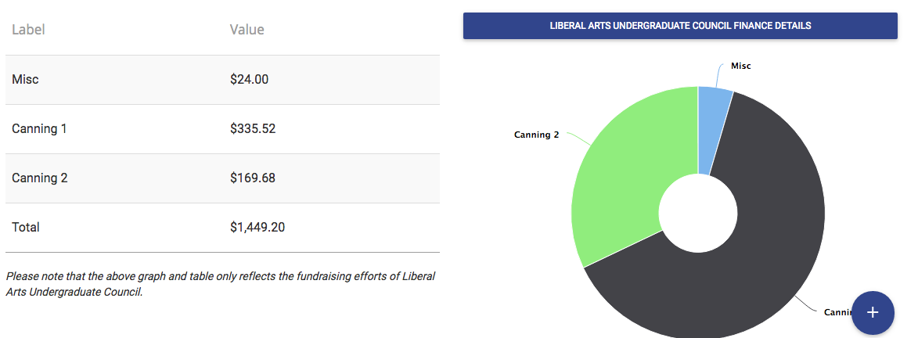
UPUA:
- Today (wednesday) February 15th in 302 HUB
  - Come at 8pm
- Resolution
  - Support the Loan forgiveness Programs
- Bill
  - Funding for the Great Debate
    - Debate occur April 26th, 2017
Programming:
Tubing at Tussey Mountain:
IMPORTANT DATE CHANGE
- Friday, February 24th from 6-9pm
- $25 for 3 hours of tubing
Sign up using the google form sent out in this week’s email and in the groupme! https://docs.google.com/forms/d/e/1FAIpQLSfKzfFIRv5CHBmCqZO6ZordXbnsj0BJmpYCdZVjQxRJnGq1lg/viewform

Betsy Devos Discussion

