Liberal Arts Undergraduate Council
Meeting Minutes 4/19/17
Start Time: 6:05pm
End Time: 6:40pm

New Exec Board:
- President: Daniel Hizgilov
- Vice President: Ryan Insley
- Treasurer: Bettina Peluso
- Secretary: Jack Ouligian
- UPUA Rep/Faculty Senator: Rachel Harrison
- THON Chair: Ryan Insley

Liberal Arts Updates:
- Justice Sally Mundy
  - April 24th at in 158 Willard at 8PM.
  - She is a PA supreme court justice who is coming to Penn State to talk about the legal and judicial career path.
- Great Debate!
  - April 26th at 8PM in 100 Thomas
  - The College Democrats and College Republicans are hosting a debate with two prominent political figures (names to be announced soon). LAUC will have tickets for all members that can be picked up at our office hours or at our final meeting next Wednesday before the event.

UPUA Updates:
- Presentation tonight
- Funding coffee for finals week
- Voting on installing sharp containers
- Faculty senate recommendations
- Safety and different skills

Programming
- Thanks for everyone who signed up!
- We will be leaving from the HUB at 5:00 am
- Students and faculty attending will be have Free time to explore the city and/or participate In the March for Science.
- We will be heading home at 6:00 pm
- Pack as light as possible
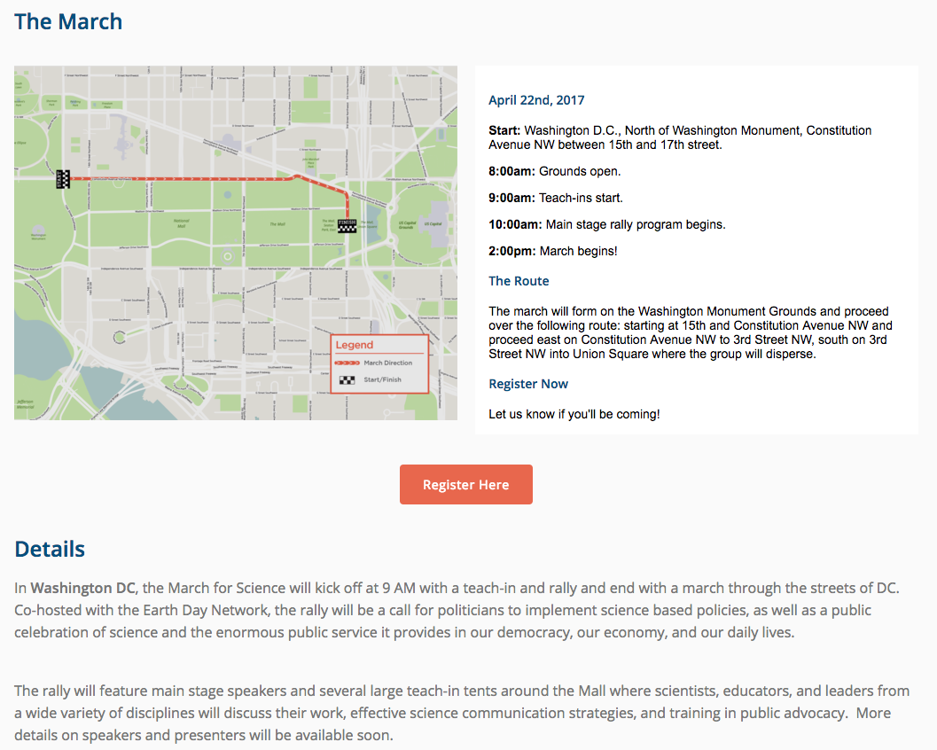
Why should we care about the March for Science and the scientific field?
- Challenging consensus
- Testing science and research
- Open to revision and development by others
- Effects individuals on a basic level
- Questions ethics that is based around the scientific community to help our quality of life
- Impacts everyone, and brings awareness to funding to help academia and research

