LAUC Meeting 9/22
Start: 6:03pm
End: 6:17pm

Faculty Senate Elections
- Micheal
Programming:
- Career Fair planning committee
  - Please let us know if you’d be interested in participating in this subcommittee
- Debate watch party
  - Oct. 9 at 9pm
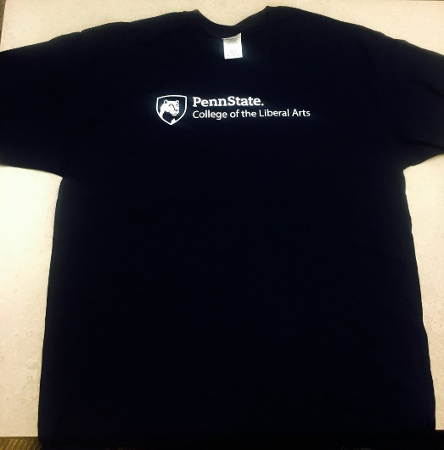
  - PSU Dems/Repubs/LAUC?
Fundraising:
- T-shirt selling booth/LAUC Promo – TBA
- Fundraisers with a restaurant – TBA
UPUA
PSU Votes Week: Sept 26-30 (Next Week)
- Starts off Monday, Sep 26
  - 11am there will be a performances (Penn State Thespians) at ground floor of the HUB
  - At 8:30 pm at HUB’s flex theater UPUA and debate association will host a Presidential debate watch party
Liberal Arts Shirts for sale - $15
SM/Med/L/XL
S
- Sep 27 (tuesday)
  - Students for Hillary and Students for Trump will debate
  - 101 Thomas at 8pm
- Sep 28
  - The College Democrats and The College Republicans will debate
  - HUB’s Flex theater at 7pm
- Sep 29
  - Legislator panel (Mayor of SC, Elizabeth Goreham, Centre County Head Commissioner, Michael Pipe and Chief of Staff to Senator Jake Corman, Matt wise)
  - 134 HUB at 5:30 pm
- UPUA and various other orgs will be on first and ground floor of HUB for voter registration
THON
- Co-THON Chair applications available on the website – Due next week, or ASAP (Email Ryan @ rci5020@psu.edu)
- Canning
Envoys
- Applications due Monday @ 12am
- Alternative Spring Break – Due Sept. 30th – Service in PA or surrounding states
  - Animal welfare, rural poverty, homeless
  - Fall/Winter/Spring
  - Previously in Baltimore
- If you have any questions pertaining to the Alt. Fall/Winter/Spring Break, ask Erik: eox5021@psu.edu
Events
- Department of State Internship
- Lunch & Learning – with employers
  - Both on Network Simplicity
- LA Network Etiquette Session
  - Oct 12, 2016 11:00 AM - 4:00 PM at HUB Alumni Hall
- Dinner in lieu of meeting next week?
  - Will send out a doodle poll soon

